
HYDROCARBON POLLUTION REMEDIATION PROJECT (HYPREP)
Project Coordination Office -Environmental Remediation Unit

Environmental Remediation of Hydrocarbon Impacted Sites in Ogoniland, Rivers State.
Phase 2 Soil and Groundwater Remediation Works on Medium Risk Sites (SMR Lots)

WEEKLY SITE ASSESSMENT ACTIVITY REPORT

Reporting Week: 3 Date: 24/07/2023 to 29/07/2023
Duration of Contract (in Months):24 Flag-Off Date: 27/04/2023 Mobilization Date: 11/07/2023
Expected End Date: 11/07/2025 Revised End Date: …../…./202
Duration on Site to Date (in Months -based on 22 Work Days per Month): 1 Months/2Days

1.0 SITE INFORMATION
LOT NUMBER |  | SMR LOT 36 | CONTRACTOR: |  |  |  |  |  | PHILCOM INTEGRATED LIMITED
SITE NAME (Name/Community) |  |  |  |  | F/S FLARE SITE AREA 2 – KWAWA COMMUNITY |  |  |  |  |  |  | UNEP Code: |  |  | qc- 016-001
L. G. A | KHANA |  |  |  |  | SITE REFERENCE GPS COORDINATES (UTM, WGS84, ZONE 32N) |  |  |  |  |  | E:509504 |  |  | N: 331632
Area (m²) of impacted soil: in the Bill of Quantities (BoQ) |  |  |  | 18,800m² |  |  | Max depth of Impact (m) in the Bill of Quantities (BoQ) |  |  | 6.0m | Volume (m³) of Soil in the Bill of Quantities (BoQ) |  |  | 112,800m³
Maximum initial Groundwater TPH (µg/l) in the Bill of Quantities (BoQ) |  |  |  |  |  |  |  | 77,000 µg/l |  | Maximum initial Soil TPH (mg/kg) in the Bill of Quantities (BoQ) |  |  | 8,800mg/kg

2.0 SITE INFRASTRUCTURE
S/No | Site Infrastructures | Quantity | Size {(LxBxH) = …………….m²/m³} -as applicable | Percentage Completion (%) | GPS Coordinates  (UTM, WGS84, Zone 32N) |  | Remarks / Working Condition
 |  |  |  |  | Easting | Northing | Remarks / Working Condition
1 | Site Offices | 1 | 27x25x3 | 90% | 509657.19 | 331728.74 | Work in progress
2 | Sewage systems | 1 | 1.54*2.2*1.54 | 80% | 509657.19 | 331728.74 | Work in Progress
3 | Decontamination area | nil |  | 0% |  |  | Yet to Progress
4 | Engineered Biocell | nil |  | 0% |  |  | Yet to Progress
5 | Leachate sump | nil |  | 0% |  |  | Yet to Progress
6 | Security Post | 1 | 2*3*2.6 | 100% | 509657.19 | 331728.74 | Work in Progress
7 | Domestic Borehole | 1 | 0.6*0.6*15 | 100% | 509657.19 | 331728.74 | Work in Progress
8 | Other

3.0 SITE HSE REPORT
3.1: Computation of Work Manhours
A | B | C | D | E
Total number of Personnel on site | Number of days worked in the week | Number of days worked from inception to date | Week Manhours  (A x B x 8hrs) | Project to Date Manhours  (A x C x 8hrs)
15 | 5 | 12 | 600 | 1,440
3.2: HSE Checks
S/N | Work Description | Number | Cumulative | Remarks
1 | Toolbox Meetings / Talks | 5 | 12 | Toolbox caried out daily
2 | Unsafe Acts / Unsafe Conditions / (UA/UC/) recorded | Nil | Nil | No UA/UC recorded on site
3 | Unsafe Acts / Unsafe Conditions (UA/UC/) Closed out | Nil | Nil | N/A
4 | Near miss | Nil | Nil | N/A
5 | First Aid case | Nil | Nil | N/A
 | Medical Treatment Case | Nil | Nil | N/A
6 | Environmental Incident | Nil | Nil | N/A
7 | Work disruption by on-site community staff | Nil | Nil | N/A
8 | Work disruption by off-site community intruders | Nil | Nil | N/A
9 | Work disruption due to breakdown of work equipment such as excavator, tiller, or bulldozer. | Nil | Nil | N/A
10 | Lost hours due to equipment breakdown | Nil | Nil | N/A
11 | Waste management practices on site – housekeeping issues | Nil | Nil | N/A
12 | Property/equipment damage | Nil | Nil | N/A
13 | Fire incident | Nil | Nil | N/A
14 | Monthly HSE meeting (s) | Nil | Nil | N/A
15 | HSE training | Nil | Nil | N/A
16 | No. of drills | Nil | Nil | N/A
17 | Fatality | Nil | Nil | N/A

4.0 ASSESSMENT SAMPLING DATA
4.1: General Boreholes Information

ITEM | QUANTITY | ITEM | QUANTITY
No. of Borehole Installed | 10 | Total No. of Soil Samples Collected | 90 (80 Organic(30 Speciated and 50 Non-speciated), 10 Inorganic)
No. of Auger holes Drilled | 10 | Total No. of Groundwater samples collected | 20
4.2: Boreholes Sampling Information
S/N | Borehole Point ID | GPS Coordinates |  | Maximum Depth (mbgs) | Soil Sampling Intervals (mbgs) | Predominant Soil Lithology | No of soil samples collected per hole | Depth range of observed Impact  (mbgs) | Predominant physical observation |  | Depth to Ground-water  (mbgs) | Observed Impact on Ground-water (Y/N)
S/N | Borehole Point ID | Easting | Northing |  |  |  |  |  | Odour | Sheen | Depth to Ground-water  (mbgs) | Observed Impact on Ground-water (Y/N)
1 | KWA2-SC-BH1 | 331698 | 509478 | 11 | 0.5, 1, 4, 7, 10 | Dark Brown, Silty Clay | 5 | 0.5-4.0 | M | M | 7.0 | No
2 | KWA2–SC-BH9 | 331836 | 509537 | 11 | 0.5, 1, 4, 7, 10 | Light brown, silty clay and grayish brown | 5 | 0.0-4.0 | L | S | 8.5 | Yes
3 | KWA2-SC-BH7 | 331760 | 509516 | 12 | 0.5, 1, 4, 7, 10 | Dark brown, silty sand, reddish gray and sand clay | 5 | 0.5-7.0 | M | S | 9.0 | Yes
4 | KWA2-SC-BH2 | 331653 | 509532 | 10 | 0.5, 1, 4, 4.5, 7 | Light brown, silty clay, reddish gray and sandy clay | 5 | 0.0-4.0 | M | M | 7.0 | No
5 | KWA2-SC-BH3 | 331668 | 509554 | 10 | 0.5, 1, 4, 7, 10 | Light brown, silty clay, and light gray | 5 | 0.0-0.5 | L | S | 9.0 | No
6 | KWA2-SC-BH8 | 331843 | 509522 | 10 | 0.5, 1, 4, 7, 10 | Light brown, silty clay, brownish gray, grayish red and yellow | 5 | 1.0-4.0 | L | S | 7.0 | Yes
7 | KWA2-SC-BH6 | 331766 | 509590 | 13 | 0.5, 1, 4, 5, 7, 10 | Yellowish brown, sandy clay, dark brown, sandy silt | 5 | 0.5-4.0 | L | M | 8.0 | No
8 | KWA2-SC-BH5 | 331847 | 509562 | 12 | 0.5, 1, 4, 7, 10 | Dark brown, silty sand, gray brown, and sandy clay | 5 | 0.5-7.0 | M | S | 9.0 | Yes
9 | KWA2-SC-BH10 | 331799 | 509547 | 11 | 0.5, 1, 2.2, 4, 5, 5.4, 7, 10 | Yellowish brown, silty clay, gray silty, dark gray and yellowish silty sand | 8 | 1.0-5.0 | M | H | 8.0 | Yes
10 | KWA2-SC-BH4 | 331697 | 509607 | 11 | 0.5, 1, 4, 7, 10 | Dark brown, silty clay, dark gray silty clay, yellowish gray, sandy clay, yellowish brown sandy soil | 5 | 0.5-4.0 | H | R | 10.5 | No
11
4.3: Auger holes Sampling Information
S/N | Auger hole Point ID | GPS Coordinates |  | Maximum Depth (mbgs) | Soil Sampling Intervals (mbgs) | Predominant Soil Lithology | No of soil samples collected per hole | Depth range of observed Impact  (mbgs) | Predominant physical observation
S/N | Auger hole Point ID | Easting | Northing |  |  |  |  |  | Odour | Sheen
1 | Kwa2-sc-ss2 | 331727 | 509500 | 5.0 | 0.5,1, 5 | Dark brown, silty clay, light yellow brown sandy clay, and yellow red sandy silty | 3 | 0.5-4.0 | M | S
2 | Kwa2-sc-ss3 | 331800 | 509500 | 5.0 | 0.5, 3, 5 | Dark brown, silty clay, light yellow brown sandy clay, and yellow red sandy silty | 3 | 0.5-4.0 | H | L
3 | Kwa2-sc-ss4 | 331789 | 509524 | 5.0 | 0.5, 3, 5 | Light brown sandy clay, yellowish brown silty clay, and grayish brown clay | 3 | 0.5-4.0 | H | R
4 | Kwa2-sc-ss7 | 331822 | 509589 | 5.0 | 0.5, 2, 5 | Dark brown sandy clay, grayish brown clay sand, and yellowish sandy clay | 3 | 0.5-4.0 | H | R
5 | Kwa2-sc-ss9 | 331711 | 509512 | 5.0 | 0.5, 2, 5 | Dark yellowish brown clay, yellowish brown sandy clay, and yellowish red sandy silt clay | 3 | 0.0-4.0 | L | S
6 | Kwa2-sc-ss8 | 331771 | 509541 | 5.0 | 0.5, 2, 5 | Dark brown sandy clay, yellowish red sandy clay, and grayish yellow sandy clay | 3 | 0.0-4.0 | M | R
7 | Kwa2-sc-ss1 | 331673 | 509584 | 5.0 | 0.5, 1, 5 | Dark brown sandy clay, light yellow clay sandy, yellowish gray sandy | 3 | 1.0-4.0 | M | R
8 | Kwa2-sc-ss6 | 331686 | 509552 | 6.0 | 0.5, 1, 5, 6 | Dark brown sand clay, light yellow clay sand, yellowish grey sandy clay, grayish sandy clay | 4 | 0.5-5.0 | M | R
9 | Kwa2-sc-ss5 | 331731 | 509601 | 5.0 | 0.5, 1, 5 | Dark brown silty clay, light brown silty clay, grayish yellow silty clay | 3 | 1.0-4.0 | M | R
10 | Kwa2-sc-ss10 | 331705 | 509574 | 6.0 | 0.5, 1, 5, 6 | Dark brown silty clay, light brown silty clay, greyish yellow silty clay | 4 | 0.5-5.0 | M | R
11
12
13
14
15
16

5.0 GENERAL ADDITIONAL COMMENTS / OBSERVATIONS
1. Prior to mobilization, office area clearing was carried out
2. Sub-Surface scanning was carried out within the week
3. Office set up still ongoing
4. Identification of sampling hand auger & borehole points
5. There are presence of carbonized materials around boreholes 5, 8, 10
6. Existence of flooded areas

6.0 SUPPORTING DOCUMENTS

- Site photos
- Sampling Logs

Contractor’s Project Manager: BARIMA JUSTICE

Sign/Date: 29/07/2023

SITE PHOTOS
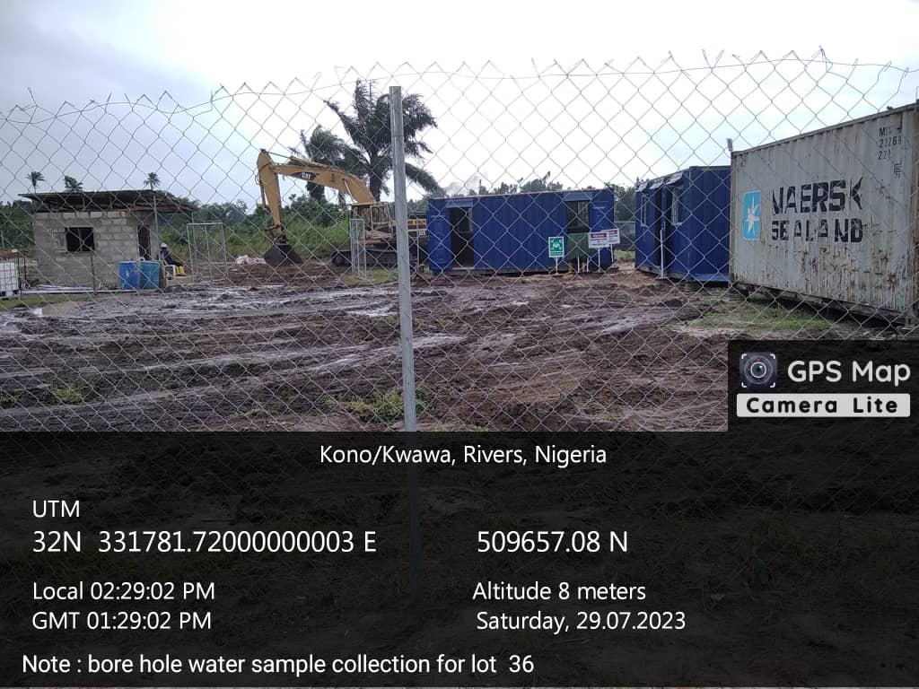

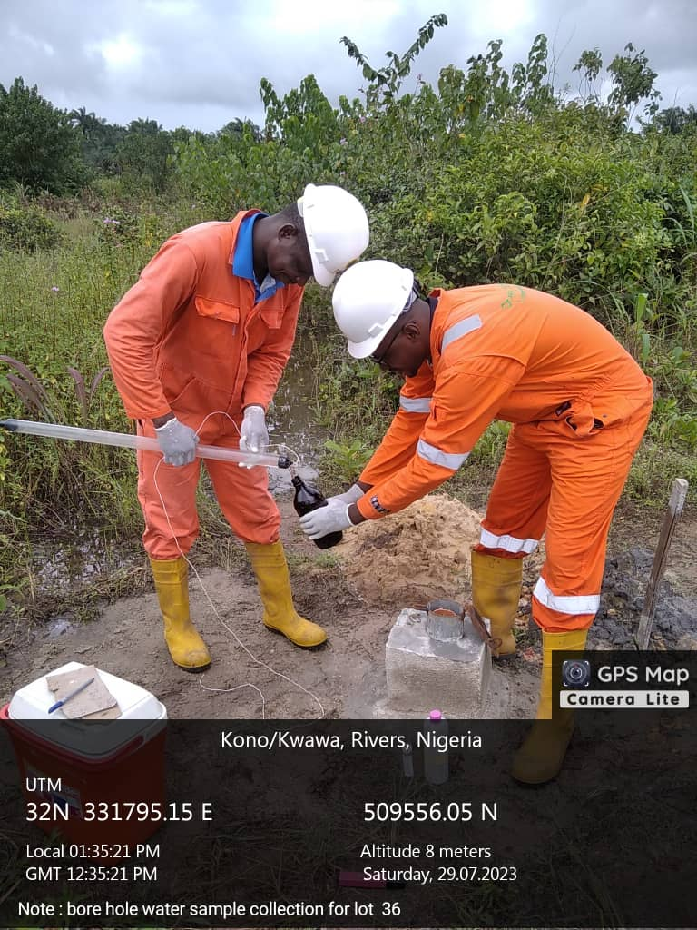
Plate 1: Office Setup

Plate 2: Sample Water Collection

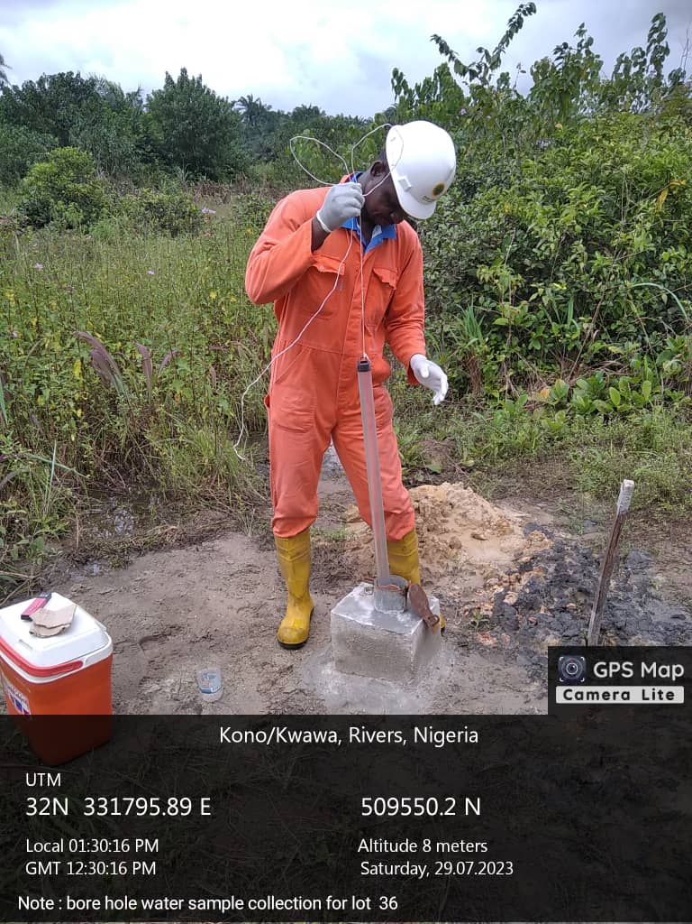

Plate 3: Sample Water Collection
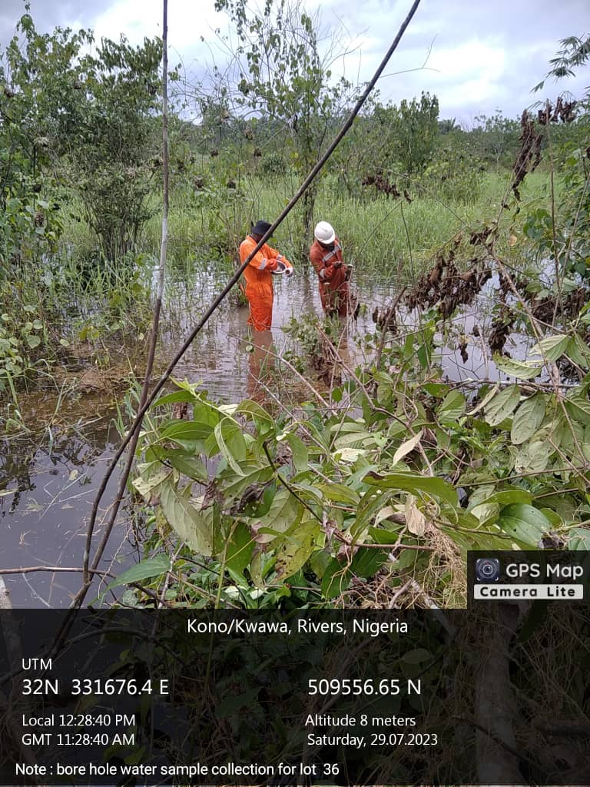

Plate 4: Auger Drilling

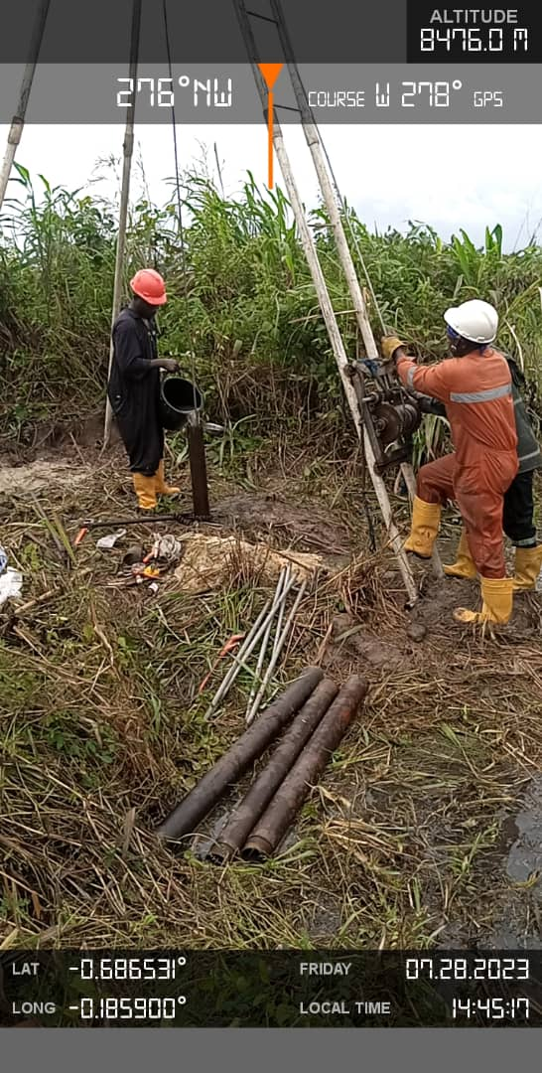

Plate 5: Borehole Installation

